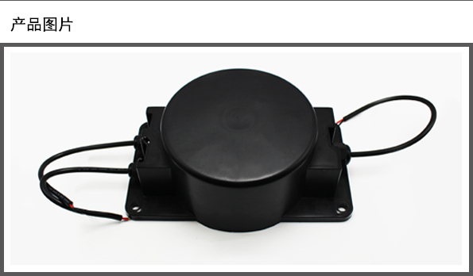

电气参数Electronical characteristics
产品型号 Production model | TTO-10230-00
额定输出功率 Rated output power | AC 500VA（可定制）
初级额定电压 Primary Rated voltage | AC 220V（可定制）
额定频率 Rated ferquency | 50/60Hz（可定制）
次级空载电压 Secondary no-load voltage | AC 0-25.2V ±5% 0-36V ±5%（可定制）
次级负载电压/电流 Secondary loaded voltage / current | AC 0-24 ±5% @ 10A 0-36V ±5% @ 7.22A（可定制）
初级空载电流 Primary exciting current | Max. 75mA(初级额定输入电压Primary rated input voltage)
安全标准 Safety standard | GB 19212.1
绝缘等级 Insulation class | Class B (130Deg.C)
接地系统Ground system | Class-I或Class-II
温升Temperature rise | 85Deg.C Max.(额定输入at reted input)
外施耐压试验Dielectric Withstand Test | AC 3.750V 5mA 1 分钟Minute(初级对次级Primary to Secondary)
感应耐压试验Induced withstand voltage test | AC 660V 200Hz 15S(初级Primary )
绝缘电阻试验Measurement of dry insulation-resistance | 100M OHM @ DC 500V

附项选择 additional item
温度保护器 Thermal Protector | 无No，但可根据客户要求增加No,but can increase according to customer’s requirement.
短路保护 Short-circuit Protector | 无No，但可根据客户要求增加No,but can increase according to customer’s requirement.
认证证书 Certification | CE、CCC、UL、CQC
静电屏蔽 Electronic shielding | 无No，但可根据客户要求增加No,but can increase according to customer’s requirement.
电磁屏蔽 Magnetic shielding | 无No，但可根据客户要求增加No,but can increase according to customer’s requirement.

